**ASSIGNMENT – 1**

1. How hidden files are created when a new user is created in the directory of the same user at that time?

Ans. Directory is made using mkdir .Hiddenfile and then, you can check by typing ls command, it wion’t be displayed. ls -al will display this hidden file.

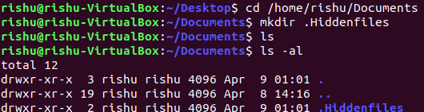

1. Make sub-directories inside a parent directory by using single mkdir command.

Ans. A parent directory ‘rishu1’ is made using mkdir -p command. ‘rishu1’ has ‘code’ and ‘blog’ in it. And, code has ‘new’ and ‘old’ in it.

